Project 11: ANSYS: Thermal+structural analysis of a semiconductor package

Problem Statement: apply thermal condition in a semiconductor package and calculate the structural deformation.

Geometry:
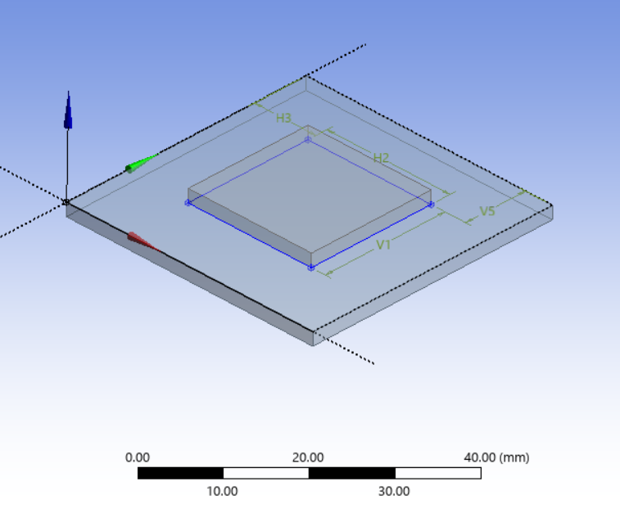

Material Properties:
Cu Die:
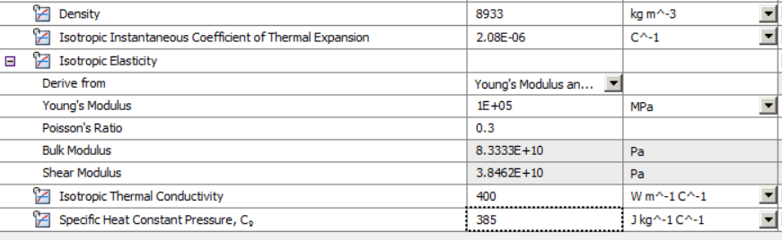

Si substrate:
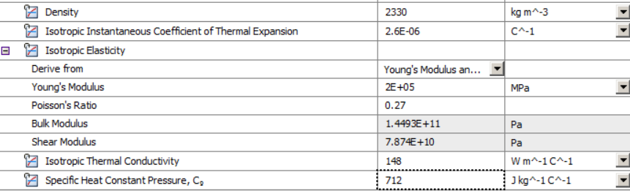

Loading and boundary conditions:
- Die has temperature of 60.
- Substrate has temperature of 40.
- Bottom surface of substrate is fixed.

Mesh: (coarse due to limitation of 1000 nodes in ANSYS educational version).
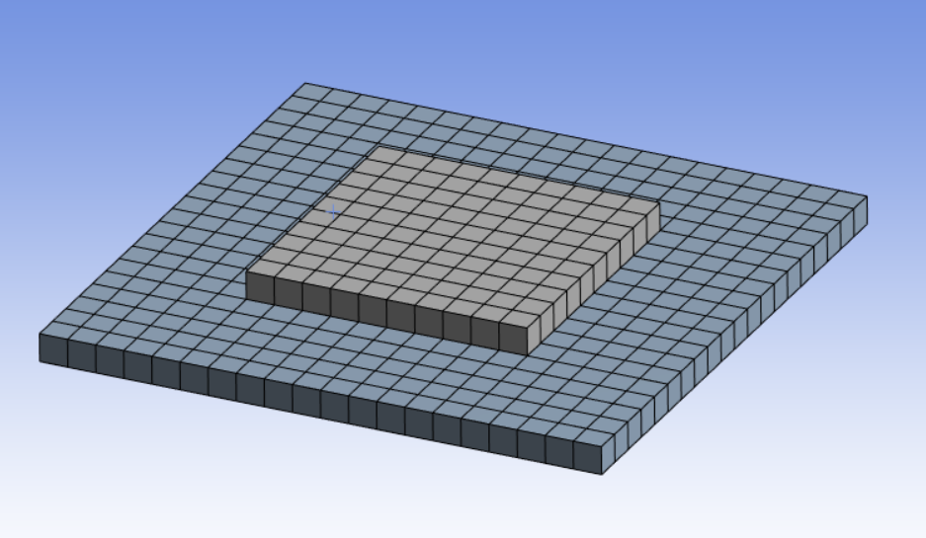

Results:
Deformation:
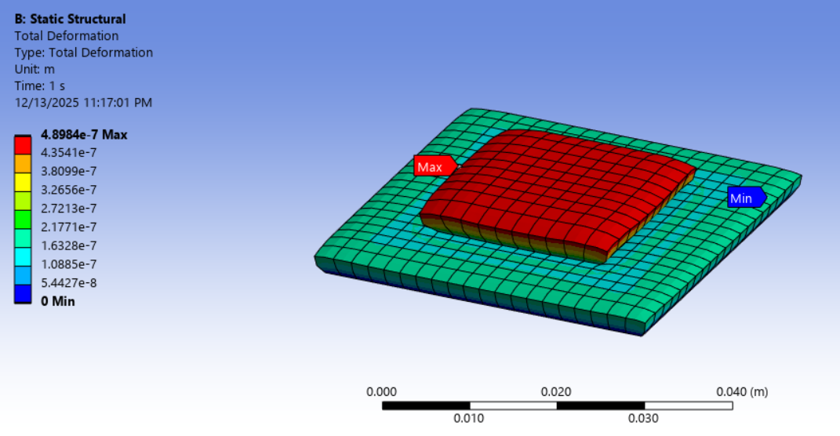

Mises Stress:
